# DAY – 4 TASK

1.TEMPLATE CREATION

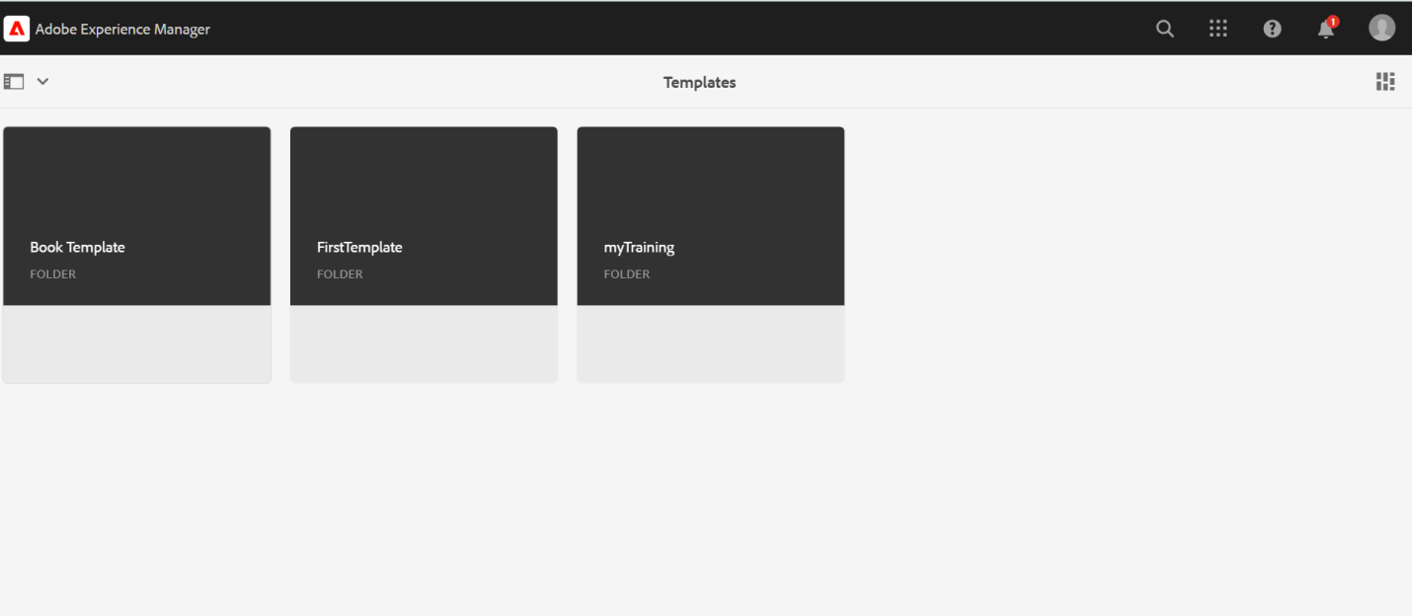

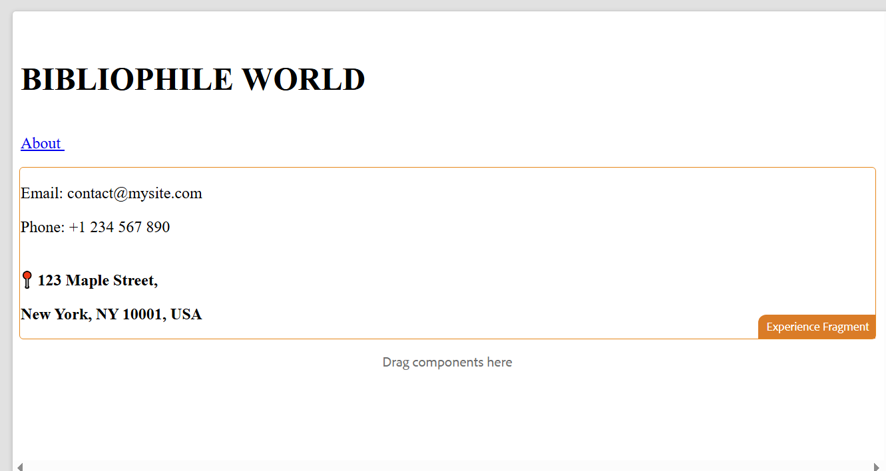

2.Page Creation

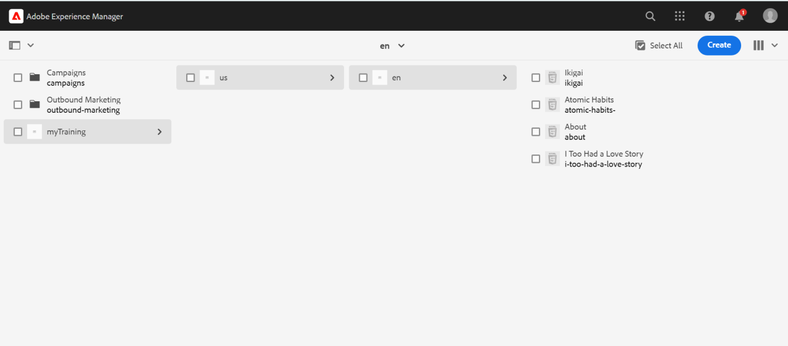

PUBLISHED PAGE

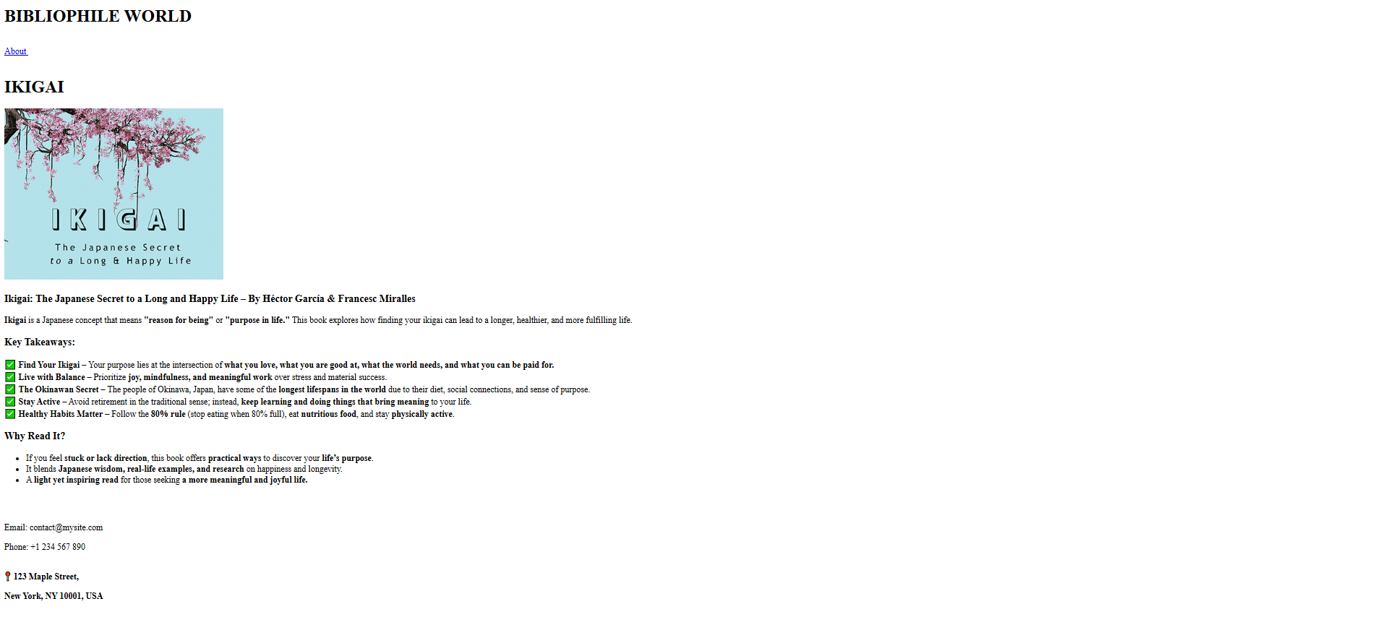

When clicked about , the about page would be navigated to new tab

